
MXEN2000 final report
Authors: Ryan Coble-Neal (19182641) and Chong Shu Luan (19218025)


Contents
Obtaining the Model from First Principles (Written by Chong) 3
Model Predictions (Written by Ryan) 12
Scenario 1 12
Scenario 2 12
Compare Predictions with Experimental Results (Written by Chong) 13
Analyse Predictions (Written by Ryan) 15
Conclusions and Reflections 16
Appendices (Written by Ryan) 18
Appendix 1 Selected Simulink model used in report (Ryan’s Model) 18
Appendix 1.1 Complete model (no masks) 18
Appendix 1.2 Solar panel subsystem 18
Appendix 1.3 Motor subsystem 19
Appendix 1.4 Drive subsystem 19
Appendix 1.5 Wheel subsystem 20
Appendix 1.6 Ramp subsystem 20
Appendix 1.7 Cart subsystem 21
Appendix 2 Other Simulink model (Chong’s Model) 22
Appendix 2.1 Complete model (no masks) 22
Appendix 2.2 Solar panel subsystem 22
Appendix 2.3 Motor subsystem 22
Appendix 2.4 Drive subsystem 23
Appendix 2.5 Wheel subsystem 23
Appendix 2.6 Cart subsystem 23

Obtaining the Model from First Principles (Written by Chong)
Solar Panel Subsystem
Silicon with doped boron and phosphorus in each side are contain in the solar cells. It converts sun energy into electrical energy. The electrons are emitted from the semiconductor when photons knock on the solar cell. If there is a closed loop circuit (Figure 1) connected to the solar cell, it will create an electric current called as photocurrent (IL). That means the higher the illuminance is provided in the circuit the more electrons will emit as the photocurrent will increase proportionally.
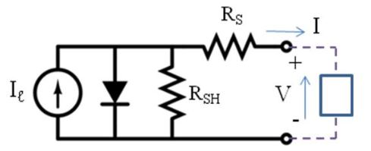
Figure 1: Simplified Equivalent Circuit Model for a Photovoltaic Cell
The equation for solar panel is$$I=I_{l}-I_{0} \left(\exp^{\frac{q\left(V+IR_{s}\right)}{nkT}}-1\right)- \frac{V+IR_{s}}{R_{SH}}$$
$$R_{s}-Resistance in series of solar cell, R_{SH}-Resistance in parallel of solar cell$$
$$V-Voltage on the load, I-Total current output, I_{l}-Photocurrent,$$
$$I_{0}-Diode saturation current, q-elementary charge\left(constant\right), k-constant$$
$$n-diode ideality factor\left(constant\right), T-temperature of the solar panel (Kelvin)$$

Assume that $R_{s}$ is too small, $R_{SH}$ is too large, so we can neglect the equation $\frac{V+IR_{s}}{R_{SH}}$ and $IR_{s}$ . Set $θ$ as the equation constant of $\frac{q}{nkT}$ . We will not take the temperature of the solar panel into account and
1 is too small so $T$ and 1 in the equation can be also neglected.

The simplified equation for output current will be:
$$I=I_{l}-I_{0}(e^{θV})$$

Therefore, the Y-intercept (short circuit current) is dependent on illumination, and the exponent is dependent on voltage for this current model.
$I_{l}$ can be determine by the equation of:
$$I_{l}= k_{0 }+ k_{1 }x$$
$k_{1 }$ is the constant slope and $k_{0 }$is the Y-intercept of of the linear line . $x$ is the illuminance that provide to the solar panel. $I_{l}$ is the short circuit current as the (Photocurrent). From the matlab linear regression, we get the graph as shown in figure 2.
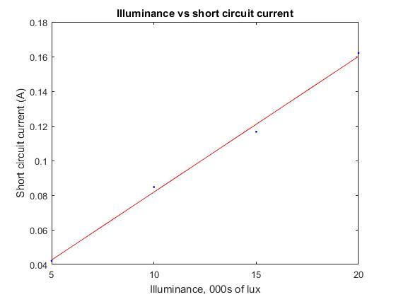
Figure 2: Short circuit current (mA)
Therefore the we get an equation of $I_{l}= 0.0034+ 0.0078x$,
$k_{0}=0.0034, k_{1 }=0.0078$ (coefficient of illuminance )
To find $I_{0}(e^{θV})$, at first we need to find the current deviation curve at varying illuminance as figure 3 shown.
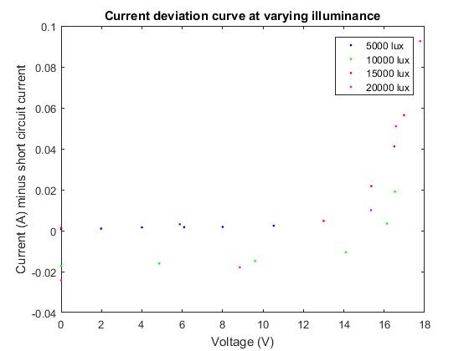
Figure 3: Current deviation vs voltage at varying illuminance
After that, find the Voltage vs log of current deviation graph as figure 4 shown.
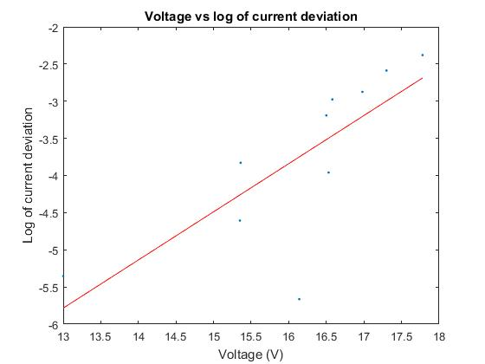
Figure 4: Voltage vs log of current deviation
From this graph we can determine the equation: $Y=\ln{I_{0 }}+ θV$
$\ln{I_{0 }}= -14.2059,$ $θ=0.6478$, thus, $I_{0 }=6.77× {10}^{-7}A$
The final equation for the solar panel subsystem will be:
$$I=(0.0034+ 0.0078x)-(6.77× {10}^{-7})(e^{0.6478V})$$
$$I=the total output current\left(A\right) to the motor, x=illuminance \left(klux\right),$$
$$V=output voltage(V) to the motor$$
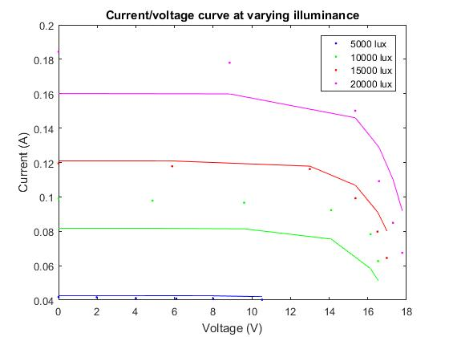
Figure 5: Raw data of Current (A) Vs Voltage(V) in variance illuminance with final regression model

Motor Subsystem
DC motor is a kindly simple mechanism. There is a coil allocated in a bunch of magnet that create magnetic field, when there is an electric current flow through the coil, the coil will be turning due to the Fleming’s right hand rule, when a current cross through a magnetic field perpendicular there will be a force created in a upward perpendicular direction to the magnetic field and the current direction. The coil is turning and it cause torque to produced. Below is a much clearer DC circuit analysis (Figure 5) that we are going to derive into our model.
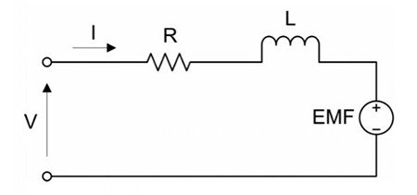
Figure 6: DC motor circuit
The total voltage of the circuit equals the voltage drops across the resistance of the coils, the inductor, and the back EMF. As the equation shown below.
$$V=IR+L\frac{dL}{dt}+EMF \sim (1)$$
$$V=total voltage in the cirucit, I=current that flows through the circuit,$$
$$R=Resistance, L=inductance, EMF=backEMF$$
The equation can be simplified by assuming the circuit is at a steady state and we set the inductor’s voltage as constant $k_{0}$.
$$V=k_{0}+IR+EMF$$
The rotation of the coil cause the EMF (back electromotive force) voltage to occur. EMF resist the provided voltage, decreasing the voltage that crossing through the motor. The equation for backEMF is shown below.
$$EMF= k_{2}∙w$$
$$k_{2}=coefficient of motor^{'}s angular speed, w=angular speed of the motor(rads/s)$$
The torque of the motor coils is directly related to the current that flows through the circuit.
$$T= p∙I$$
$$I=T/p$$
$$p=constant$$
We can substitute the current to the voltage equation 1.
$V=k_{0}+\frac{TR}{p}+k_{2}∙w$, Set $\frac{R}{p}$ to $k_{1}$ , because R and p is a constant
Final equation will be: $V=k_{0}+k_{1}∙T+k_{2}∙w$
$$V=voltage provided to the current , k_{0}=constant for inductor,$$
$$k_{1}=coefficient of torque, T=torque of the motor,$$
$$k_{2 }=coefficient of angular speed, w=angular speed of the motor$$
We need to find out the constant, and the coefficient in the equation through matlab linear regression, in order to model it the Simulink with the equations.
At first, we will insert the angular speed(rads/s) vs torque(Nm) through variance voltages data into matlab. After that, create a big X matrix with ones and Y matrix and use the equation show in appendix to find out the intercept, coefficients of torque and motor. The value is shown as below.
$$k_{0}=0.0532, k_{1 }=0.0115, k_{2}= -0.0141$$
The model equation will be:
$$V=0.0532+0.0115T-0.0141w$$
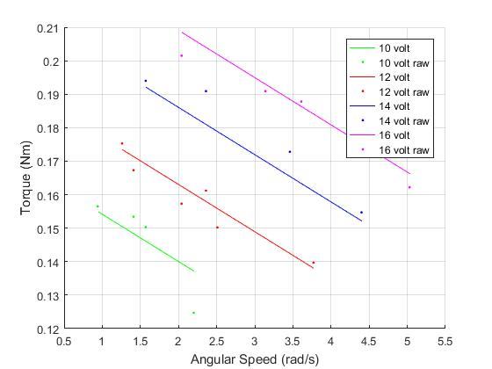
Figure 7: Raw data Torque(Nm) Vs Angular Speed(rad/s) in different voltages with regression model
Besides, there is another part of equation that is needed to be derived to suit the model. We need to take current into account for the model. The torque of the motor is proportional to the strength of the magnetic field and the current that flows through the coils. The magnetic field is a constant as assume. The equation can be shown below.
$$I=a_{0}+a_{1}T$$
$$I=current across motor coils, a_{0}=constant of magnetic field,$$
$a_{1}=coefficient of torque, T=torque of the motor$
To obtain the the constant and coefficient value by inserting the data of current (A) vs Torque (Nm) of the motor with variance of voltages into the matlab.
The final value that is been obtained:
$$a_{0}=-0.0082, { a}_{1}=1.6379$$
The final equation for modelling:$$I=-0.0082+1.6379T$$
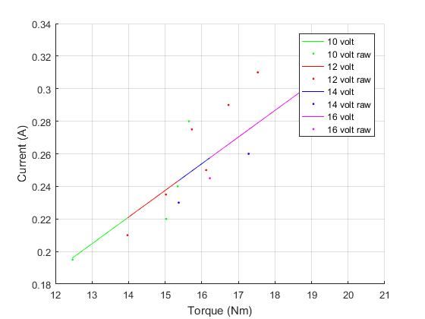
Figure 8: Raw data of Current(A) Vs Torque (Nm) graph in variance voltages with regression model

Drive Subsystem
Gear can transfer power and arrange the mechanical advantage of a mechanical system such as car’s tyre. A motor with a 1:1 ratio of gear will not be powerful to drive a heavy load as the body and the solar panel. With a really fast motor will end up with a lesser torque output and it would not carry a load with heavy mass. The mechanical advantage will changes accordingly with the speed of motion. The rate of work done is equal to power. Therefore, the amount of work done decreases, the speed to finish the work will increase. As it is inversely proportionally to each other. Equation as shown below. Gear ratio is needed to balance out between the torque and the speed of the tyres.
$$P=\frac{W}{t}$$
$$P=power, W=work done, t=time taken to do the work$$
We have chosen a 2:1 gear ratio as we get a 25 teeth of driving bevel gear and a 50 teeth of driven bevel gear.
Gear Reduction = Driven gear teeth/ driving gear teeth
Output Torque = Input Torque $×$Gear Reduction
Output Angular Speed = Input Angular Speed/ Gear Reduction
Furthermore, we estimated that the drive loss will be 20% so the equation for the Simulink will be as below:
$$T_{o}=T_{m}×R×D$$
$$T_{o}=Output Torque\left(Wheel\right)\left(Nm\right), T_{m}=Input Torque\left(Motor\right)\left(Nm\right),$$
$$R=Gear Ratio=2, D=percentage after drive loss=0.8$$
$$W_{m}=W_{w}×R$$
$$W_{w}=Angular Speed \left(Wheel\right)\left(\frac{rads}{s}\right), W_{m}=Angular Speed\left(Motor\right)\left(\frac{rads}{s}\right),$$
$R=Gear Ratio$ =2
Wheel Subsystem
We need to convert the torque output from the wheel into force to make the cart move up the ramp and also the tangential velocity of the wheel that can be obtain in the cart subsystem is needed to convert into angular speed of the wheel. The equation is shown below.
Torque = Force $×$ Radius of the wheel
Tangential Velocity = Angular Speed of wheel $×$ Radius of the wheel
Simulink model shows, $$F=T_{in}/R$$
$$F={Force output(N) , T}_{in}=torque from wheel \left(Nm\right), R=Radius of the wheel(m)=0.03$$
$${W_{w}=V}_{t}/R$$
$$W_{w}={Angular speedof wheel, V}_{t}=Tangential Velocity, R=Radius of the wheel(m)=0.03$$
Cart Subsystem
After the experiment of C1 and C2, we found out that the cart has a frictional losses during moving up on the ramp due to the fact of rolling resistance and bearing losses. The frictional losses can be easily measured by making a cart rolling down the ramp. Kinetic coefficient can be determined by rolling cart down the ramp. Besides, the static frictional coefficient can be determined by pulling the cart with a spring balance, as the tyres are clamped to not moving, so that we can get a slipping data as the static coefficient. The kinetic coefficient equals to 0.0783 and the static coefficient equals to 0.65, we get the value from the experiment C1 and C2. Moreover, to get the tangential velocity of the cart we need to first obtain the acceleration of the cart by summing up all the force that is acting on the cart, divide it to the total mass. After that, integrate the acceleration and we will get the velocity of the cart to input back the wheel subsystem. We are using the Newtons 2nd law of motion to solve this model. Equation shown below:
$$ΣF=ma$$
$$ΣF=net force acting on the cart, m=total mass of the cart, a=acceleration of the cart$$
Figure 9 show the whole free body diagram of the cart system that need to be derive.
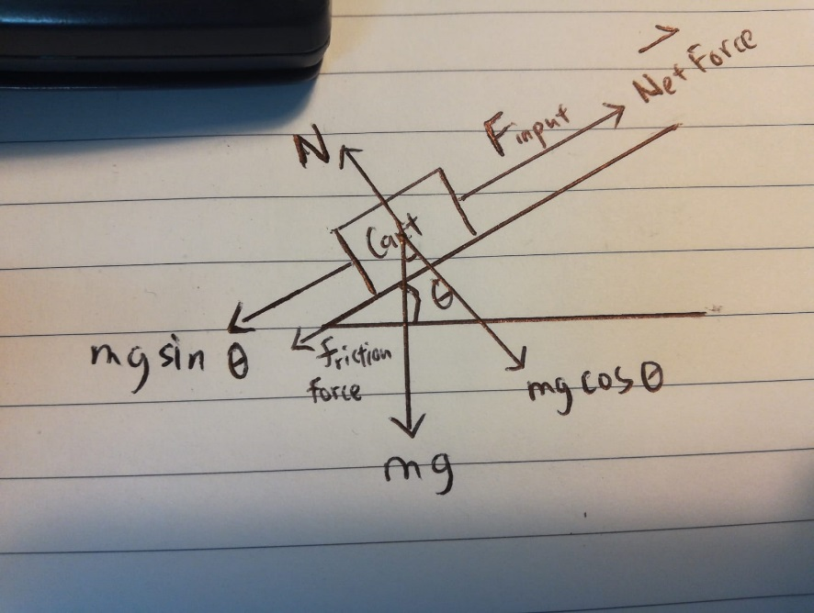
Figure 9: Free body diagram of the cart on the ramp
$$Net Force =Force\left(Wheel\right)-mgsinθ\left(Force due to gravity\right)-mgcosθ∙k_{kinetic}(Frictional Force)$$
$$ΣF=F_{in}- mgsinθ- mgcosθ∙k_{kinetic}$$
$$ma=F_{in}- mgsinθ- mgcosθ∙k_{kinetic}$$
$$a={(F}_{in}- mgsinθ- mgcosθ∙k_{kinetic})/m$$
$$a=acceleration of the cart(ms^{-2}), F_{in}=force input(N), m=mass of the cart(kg)(1.348),$$
$$θ=angle of the ramp(degree)(8°),$$
$$g=gravity of acceleration=9.81ms^{-2}, k_{kinetic}=coefficieant of kinetic friction=0.0783$$
Before running the model for this we need to add a slip check in the system. When the net force is larger than the force due to static friction. The tyre of the cart will start slipping. Therefore, a relational operator is needed to add into the Simulink to stop simulation when the total force>force due to static friction. As equation shown below:
If $(F_{in}- mgsinθ- mgcosθ∙k_{kinetic})>(mgcosθ∙k_{static}$)$→the cart will start slipping(stop simulation)$
$$k_{static}=coefficient of static friction=0.65$$
After finding the acceleration of the cart and we have confirmed the cart is not slipping, we can start integrate the acceleration into velocity and velocity integrate into the displacement of the cart. We can add two integrator blocks to the acceleration part to find out the velocity and the displacement of the cart. With the velocity part, we will connect it as an input of the wheel subsystem. To determine the time taken for the cart to drive up a particular angle and 1 metre long ramp. We need to add a Ramp subsystem to convert degree to radians as Simulink can read radians only. Besides, we need to add a compare to constant block at the end of the displacement to show that when the displacement react 1m the simulation will stop, and the time will be shown on the display. The equation for integrating as shown below:
$$\int{adt}=v, \int{vdt}=d$$
$$a=cart acceleration cart , v=cart tangential velocity, d=cart displacement$$

Ramp Subsystem
This subsystem is just convert degree into radians with the equation below:
$$r=θ∙\frac{π}{180}$$
$$r=radians of the angle\left(rads\right),θ=angle in degree, π=pi$$

Model Predictions (Written by Ryan)

Scenario 1
Angle (degs) | Illuminance (KLux) | Added Mass (kg) | Predicted Time (s) | Actual Time (s)
8 | 17 | 0.25 | 6.53 | 5.7

N.b. The predicted time given is from the model used on the day which had 2 errors that are not present in the model given in Appendix 1 (wrong use of gear ratio and an incorrect parity)
The total work done by the cart can be found from the equation Work = Force x Displacement. There is a sharp increase in work from rest to the cart reaching its steady state speed however, this time period is sufficiently small to calculate work from just the steady state motion. Using a product block on the input force acting on the cart and the displacement of the cart, work is 0.63J at steady state.
The effective output power can be found from the equation Power = Work/Time. With an actual time of 5.7s the power is 0.11W.

Scenario 2
Angle (degs) | Illuminance (KLux) | Added Mass (kg) | Predicted Time (s) | Actual Time (s)
11 | 27.5 | 0.5 | 11.46 | 6.25

The work done at steady state speed using the same method as above comes to 0.83J. This yields an effective power output of 0.133W.

Compare Predictions with Experimental Results (Written by Chong)
We have a longer time that is predicted than the measured time during the last lab and the difference are too huge in the scenario 2, it should be the Simulink equations that make the differences. Therefore, we changed some variables in the model and obtain a more accurate time taken for the cart to move up the ramp. In this section of the report we will be comparing between the more accurate time taken and the experimental result instead of using the previous result during the last lab into the comparison. The experimental result for scenario 1 is 5.7 seconds as we predicted 5.576 seconds. We get a 2.18% of error. Measurement shown as below:
$$Percentage Error= \frac{\left|5.576-5.7\right|}{5.7}×100\%$$
= 2.18%
In scenario 2 the experimental result is 6.3 seconds in average, we predicted 10.35 seconds.
$$Percentage Error= \frac{\left|10.35-6.3\right|}{6.3}×100\%$$
= 64.29%
There are a lot of discrepancies occur in scenario 2. There are several key causes that cause these errors. First of all, we think that we did not take the temperature of the solar panel and the motor into account for the model. Photocurrent of the solar panel is usually depends on the irradiance and temperature. With the equation below:
$$I_{l}={\frac{G}{G_{ref}}(I}_{l,ref}+μ_{sc}∙∆T)$$
$$I_{l}=photo current\left(A\right), G=irradiance\left(\frac{W}{m^{2}}\right),{ G}_{ref}=irradiance at STC\left(\frac{1000W}{m^{2}}\right),$$
$$∆T=T_{c}-T_{c,ref}\left(Kelvin\right), T_{c,ref}=Cell temperature at STC\left(298K\right),$$
$$I_{l,ref}=Photocurrent \left(A\right)at STC,$$
$$μ_{sc}=Coefficient temperature of short circuit current (\frac{A}{K})$$
Moreover, the diode current ($I_{0})$is also affect by the temperature of the solar cell. With the equation below:
$$I_{diode}= I_{0}\left[\exp\left(\frac{V}{A∙N_{s}∙V_{T}}\right)-1\right]$$
$$V_{T}=k∙T_{c}/q$$
$$I_{0}=reverse saturation current of the diode\left(A\right),T_{c} is current cell temperature \left(k\right)$$
$$k=Boltzmann constant\left(1.381×{10}^{-23}\frac{J}{K}\right), q=electron charge \left(1.602×{10}^{-19}C\right)$$
$$V_{T} is named as thermal voltage \left(dependance on temperature\right),$$
$$N_{s}=the number of solar cell connected in series,$$
$$A is a constant (identity factor that depends on solar cell technology)$$
There is temperature in the equation and we need to take it into account to get a more precise output current and output voltage. As the temperature can affect the power output of efficiency. The higher the temperature the solar cells have the less power output will be. As the energy lost due to transfer solar energy into some heat energy instead of turning it into electrical energy. This can be explained when the large amounts of photons carry with energy and light bang onto the low energy states electrons into high energy states and these high energy electrons will bang into other molecules in the solar cell before flowing out to the DC motor, this additional energy that the electrons loss turn into heat instead of current. The molecules in the solar cells will be vibrating more rapidly when the temperature of the solar panel is increased and this will prevent electrons getting out from the solar cell as the electrons will bang into these molecules more easily. This make more sense as in scenario 2 we have a higher illuminance acting on the solar panel, this will make the solar panel get warm faster and that is why we have larger errors percentage in scenario 2 than scenario 1.
In the other hand, another discrepancies is the fact that we did not take the power loss of the motor into proper account. We only assume there will be 20% of loss, but in real cases we need to predict the total power loss with a certain range of percentage by inputting varies data of torque, and angular speed correspond to the electrical variables into the matlab to get a total linear regression of total power loss from electrical power to mechanical power. Besides, we are supposedly to conduct an experiment in C3 to determine the mechanical loss after converting from a gear ratio, but in the end we end up not enough time conducting C3 experiment. These cause the data that we predicted to be inaccurate.
In addition, we used different sizes of wheels in the front of the cart, so the total tangential velocity of the cart will slightly affect by it as we did not take each tyres in a free body diagram into account. The front tyres frictional force will be slightly different with the back of the wheels. Besides, to get a more accurate data we need to calculate the centre of mass of the cart and put the additional mass on top of it to not affect the whole mass equilibrium while it is moving up the ramp.
We found out some limitation to our model, it cannot effectively show the minimum light intensity to drive the whole cart up a certain angle of ramp. Unless you try it one by one by adding each light intensity into the model and see how the Simulink respond to it. This will be a tedious way to predict it. Besides, we cannot effectively show the maximum mass that the cart can afford to move in a specific illuminance if not we need to add each particular mass each time try and run the cart to obtain the maximum mass for the cart to move in a specific illuminance.

Analyse Predictions (Written by Ryan)

There is a maximum incline that the model predicts the cart could climb with the conditions of Scenario 1 at 10.8 degrees the cart will take an estimated 13.66s to climb the 1m ramp, however at this stage it will likely be at its slipping point. The cart will likely take longer than this time to climb the ramp as it will most likely slip teeth in the drive train or slip with the drive wheels.
There is an optimal gear ratio of two according to the model that minimises the ascent time in Scenario 1 to 5.576s. N.b. The time given here is different to the time predicted by the original model used on testing day as the model in Appendix 1 has the two aforementioned errors fixed.
There is a minimum light intensity of 14Klux required to move the cart up the ramp with the conditions given in Scenario 1. This minimum illuminance results in a predicted travel time of 22.8s to climb the 1m ramp.
There is a maximum total mass the model predicts the cart can haul without slipping in the conditions given in Scenario 1 of (1.348 + 0.65) kg i.e. an added mass of 0.65kg. This is starkly incorrect as by actual testing we found the cart could haul much more than this at this light intensity.

Conclusions and Reflections
(Written by Chong)
In short, we are not satisfied with the quality and accuracy of the model due to the huge amount of percentage error that we have in scenario 2. Our model can be improved by adding the temperature of the solar panel into our model. The power loss of electrical power to mechanical power needed to take into account in the model. As there is a lot of power loss during the converting of electrical power to mechanical power due to heat loss of solar panel and magnetic loss in the DC motor. The efficiency of the output power is needed to calculate. If we have given more time on doing the experiment, we will complete C3 experiment and adding a precise mechanical power losses in a loaded gear box after converting power the through the gear ratio. Besides, we will add some subsystem in it to be able to identify the max load of the cart can move with, the minimum light intensity to drive the cart, and the max angle of the ramp that the cart can move up.

2. Tried and error in an experiment based on an idea is kind of hazard as compared to the experiment that already designed to be simple and accurate as theory allows. However, tried and error learning will increase the mental mindset as a engineer. Persistency is one of the main aspect to achieve a certain goal and with tried and error you can learn this aspect throughout the experiment. As tried and error is more time consuming than designed simple and accurate theory for students to followed. Besides, you will at least have a goal to follow for each experiment but you will do less research and think less while doing the experiment. As try and error is the fundamental approach of problem solving. Although, tried and error will not always produce a good result at the end of it, but the learning process is valuable for every student. Students tend to remember the solving methods and the theory behind an experiment clearly because they have overcome a lot of obstacle during the experiment. Our brain normally works to remember stuffs that we face hardship a lot with. As a future engineer, we will face a lot more of various challenges outside the working field. Therefore, to create a mindset of creativity and persistence is important to students.

State two things that make modelling complex:
One of the complex things that we have face is the equations for each block systems. We are not sure how each block system is connected to each other. One of the abilities can be improved by keep trial and error on the subsystem connect it sequentially and think the whole process of the system works from the beginning to the end of it. From the solar panel, and where the solar panel is connected, after that think of what is the output of the solar panel will be and what system is needed to receive the output of the solar panel etc. The another complex is to know what kind of parameters need to take into account for the final model and converting the parameters into equation that can be calculated in the Simulink. We need to do more experiment on the cart with different parameters to able obtain the parameters and try to convert those graph of data that we obtain from experiment into equation.

(Written by Ryan)
A detailed model depending on assumed data is deeply flawed from its conception and would result in a predictions that do not accurately represent the factors contributing to an outcome of an experiment. Not only is this approach unreliable and inaccurate by nature, but a detailed model takes time to put together and to base it on data that does not represent the system that the model is being designed for will lead to a big waste of time. A reasonably simple model that is based on empirical data will produce far more accurate predictions with less effort. These predictions can be finetuned later via statistical analysis involving the minimisation of cost functions as well as applying new theories to discover previously unmodelled parameters and variables e.g. frictional losses.
I have learned the value of statistical analysis when it comes to optimising a model to include the correct number of variables that can be accounted for in a multivariate relationship e.g. the minimisation of cost functions. More importantly however, I have learned of the importance of planning of experimental procedure and recording data in a succinct and reliable way.
Experimentation can be made complex by a lack of discipline when it comes to consistency between trials as well as improper experimental design. Allowing variables that are meant to be kept constant to change in between trials can gravely undermine the reliability of the data and ultimately the validity of the experiment. This can result in further statistical analysis being skewed to the point where a model based on these analyses would not accurately predict the system it was designed to predict. The improper design of an experiment can lead to wasted time and invalid data which, like before, can lead to models that do not represent the system they were designed to represent. An improvement I can make to reduce the error that comes from this general lack of discipline would be to actively think about my experiments in the time leading up to designing and carrying them out i.e. in spare time contemplating experimental design while keeping an eye on the expectation of the experiment’s results. As a result of this active thinking I would have more clarity during my design of experimental procedure as well as keeping the bigger picture of what I want to achieve from an experiment in mind while carrying out an experiment.

Appendices (Written by Ryan)

Appendix 1 Selected Simulink model used in report (Ryan’s Model)

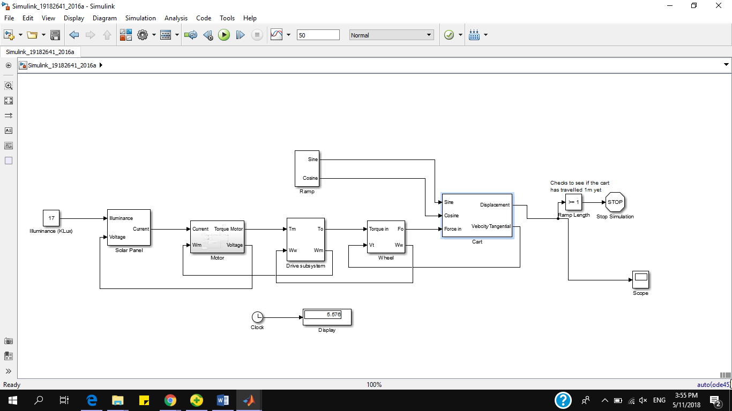
Appendix 1.1 Complete model (no masks)

Appendix 1.2 Solar panel subsystem
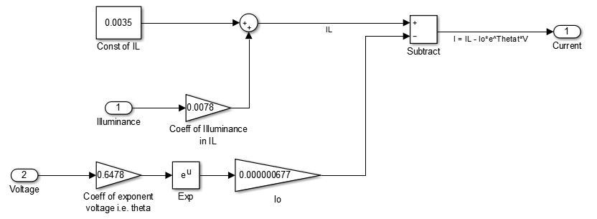

Appendix 1.2.1 Governing equations for solar panel subsystem
$I=I_{L}-I_{0}e^{θV}$ where $I$ = total current (A), $I_{L}$ = 0.0035 + 0.0078x, where x is the illuminance and $I_{L}$ is the light determined current (A), $I_{0}$ = diode saturation current (6.77x${10}^{-7}$A), $θ$ = constant (0.6478), V = voltage (V)

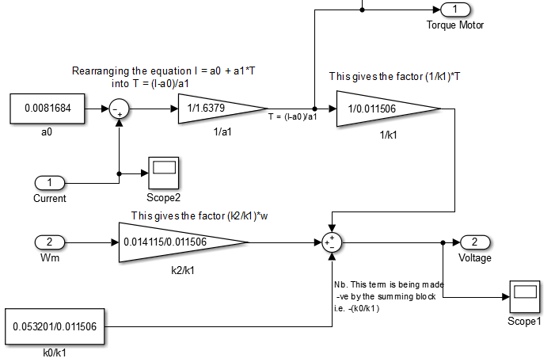
Appendix 1.3 Motor subsystem

Appendix 1.3.1 Governing equations for motor subsystem
$T=\frac{{(I-a}_{0})}{a_{1}}$, $V=-\frac{k_{0}}{k_{1}}+\frac{T}{k_{1}}+\frac{k_{2}}{k_{1}}ω$ where $T$ = torque (Nm), I = current (A), $a_{0}$ = constant (0.008164), $a_{1}$ = constant of proportionality (1.6379), V = voltage (V), $k_{0}$ = constant (0.0532), $k_{1}$ = constant of proportionality (0.011506), $k_{2}$ = constant of proportionality (0.014115), $ω$ = angular speed (radians/s)

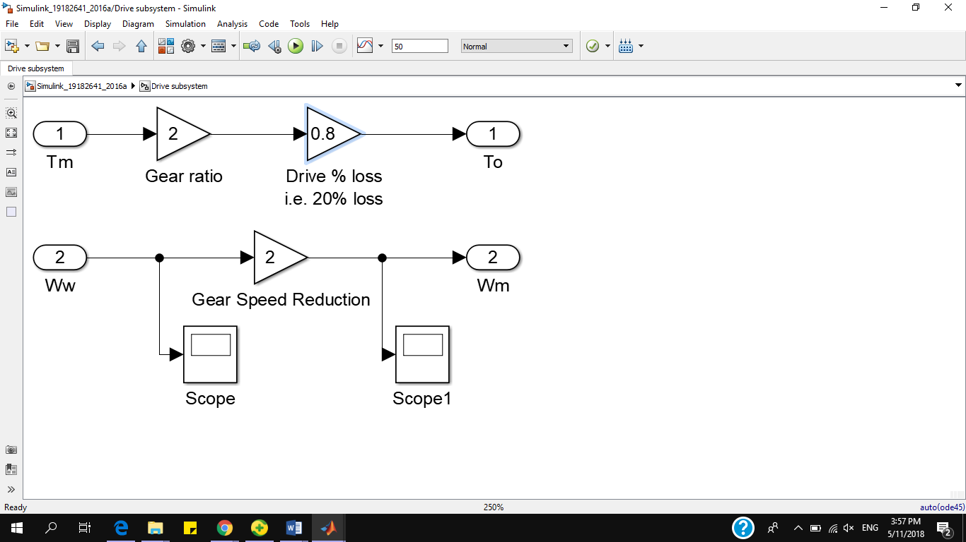
Appendix 1.4 Drive subsystem

Appendix 1.4.1 Governing equations for drive subsystem
$T_{o}=1.6T_{m}$, $ω_{m}=2ω_{w}$, where $T_{o}$ is the torque outputted by the drive train (accounting for a frictional loss of 20%) and $T_{m}$ is the torque generated by the motor at the output shaft. $ω_{m}$ is the angular speed of the motor’s output shaft and $ω_{w}$ is the angular speed of the wheel.

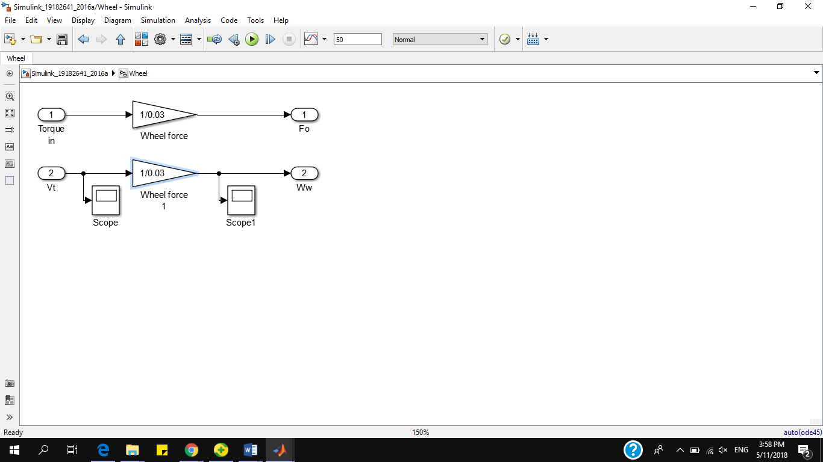
Appendix 1.5 Wheel subsystem
Nb. 0.03 corresponds to the wheel’s radius of 3cm i.e. 0.03m.

Appendix 1.5.1 Governing equation for wheel subsystem
$F_{o}=\frac{{Torque}_{in}}{r}$, $ω_{w}=\frac{V_{t}}{r}$, where $F_{o}$ is the force at the output of the wheel i.e. the contact force with the ramp, ${Torque}_{in}$ is the torque being applied to the wheel by the drive train, $r$ is the radius of the wheel in meters i.e. 0.03m, $V_{t}$ is the tangential velocity of the wheel i.e. the velocity of the cart.

Appendix 1.6 Ramp subsystem
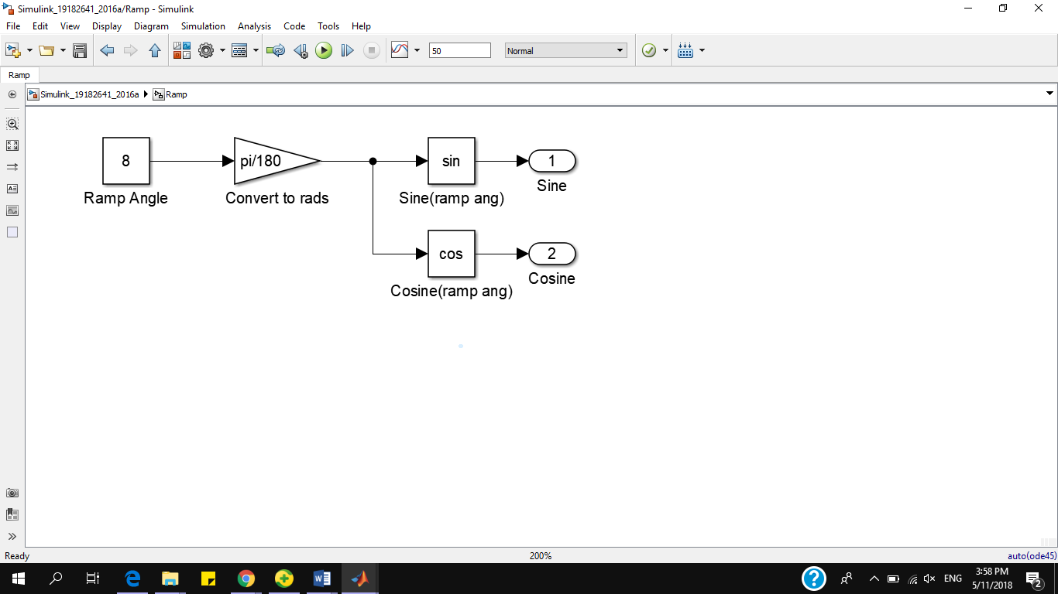

Appendix 1.6.1 Governing equation for ramp subsystem
$θ_{rads}=\frac{π}{180}*θ_{degs}$, this is a standard equation to convert an angle in degrees to an angle in radians which can be used by Simulink to perform trigonometric equations including sine and cosine with.

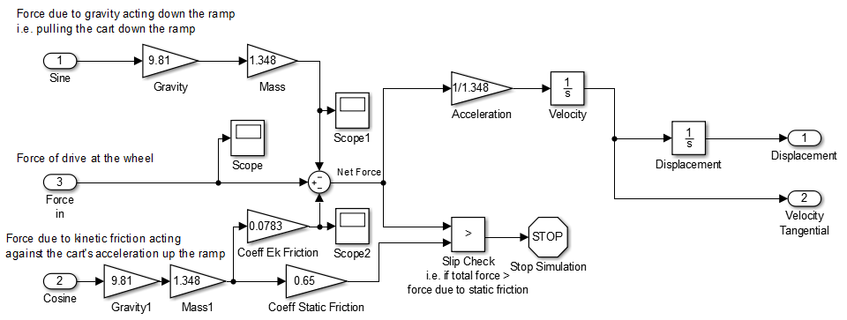
Appendix 1.7 Cart subsystem

Appendix 1.7.1 Governing equation for cart subsystem
$F_{g}=mgsinθ$, $N=mgcosθ, F_{f}=μ_{k}N$, $F_{s}=μ_{s}N$, $F_{net}={F_{in}-(F}_{g}+F_{f})$, $a=\frac{F_{net}}{m}$, where $F_{g}$ is the force due to gravity acting down the ramp, $m$ is the mass of the cart (1.348kg), $N$ is the normal force, $g$ is the acceleration due to gravity (9.81m$s^{-2}$), $F_{f}$ is the frictional force due to kinetic friction, $μ_{k}$ is the coefficient of kinetic friction (0.0783), $F_{s}$ is the static frictional force, $μ_{s}$ is the coefficient of static friction (0.65), $F_{net}$ is the net force acting on the cart, $F_{in}$ is the input force acting at the wheel’s contact with the ramp.

Appendix 2 Other Simulink model (Chong’s Model)

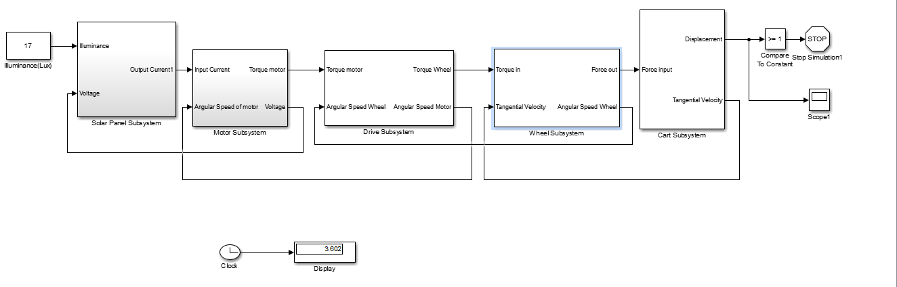
Appendix 2.1 Complete model (no masks)

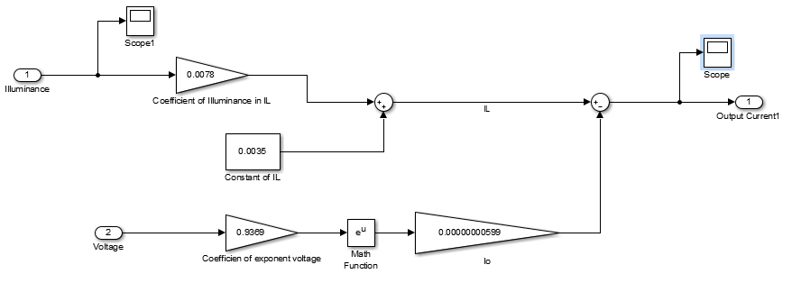
Appendix 2.2 Solar panel subsystem

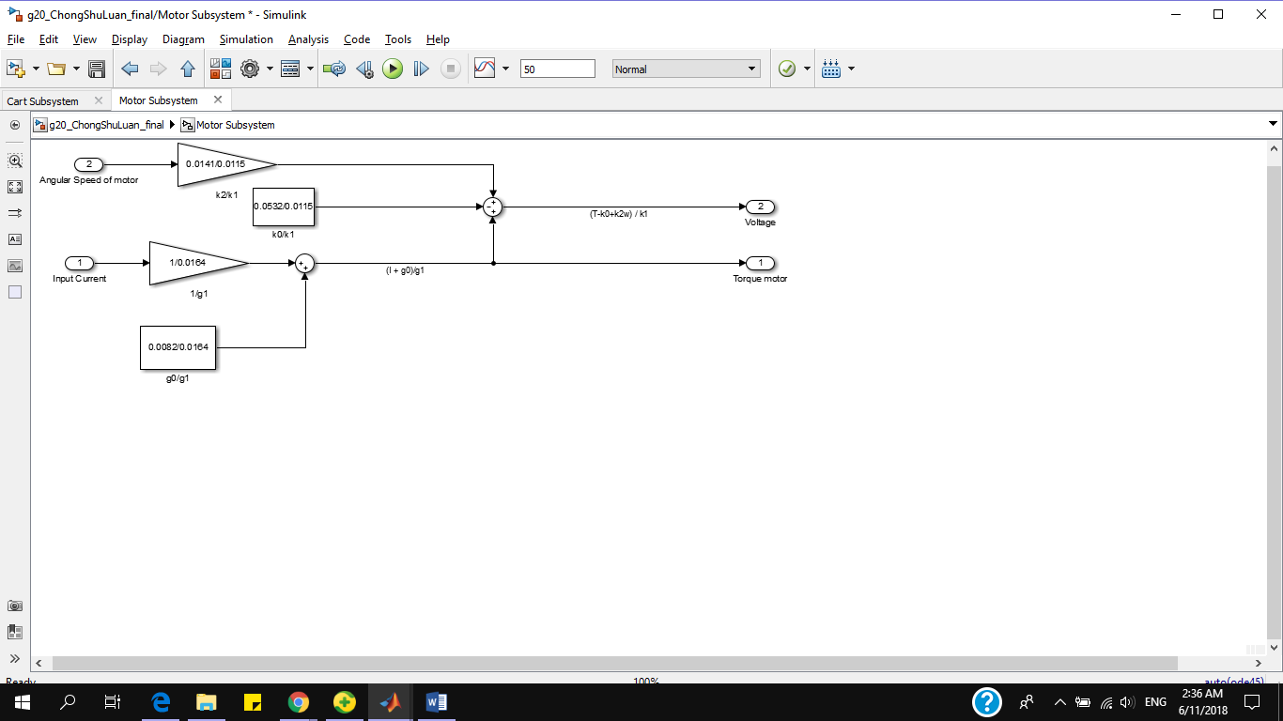
Appendix 2.3 Motor subsystem

Appendix 2.4 Drive subsystem

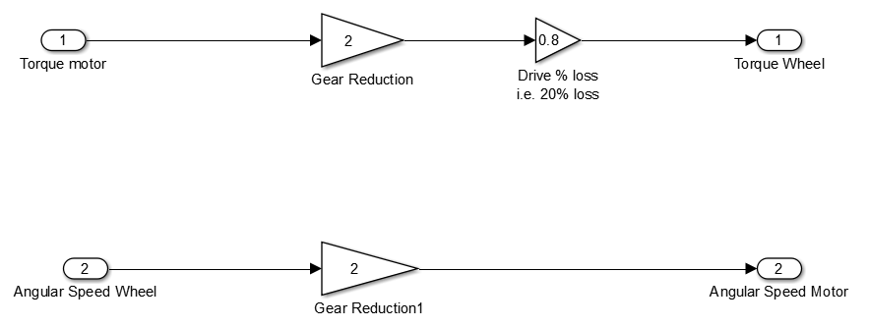

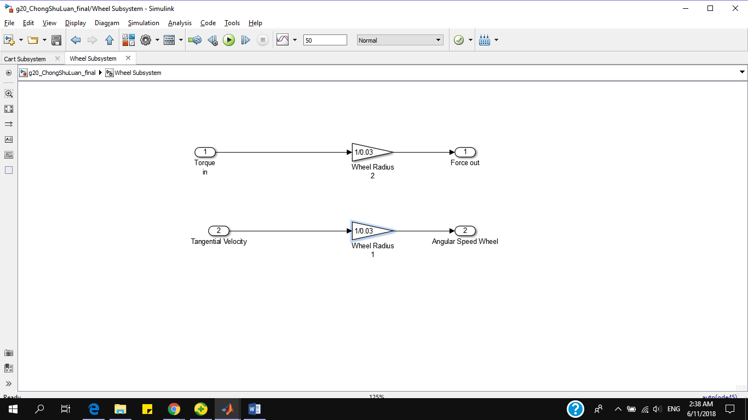
Appendix 2.5 Wheel subsystem

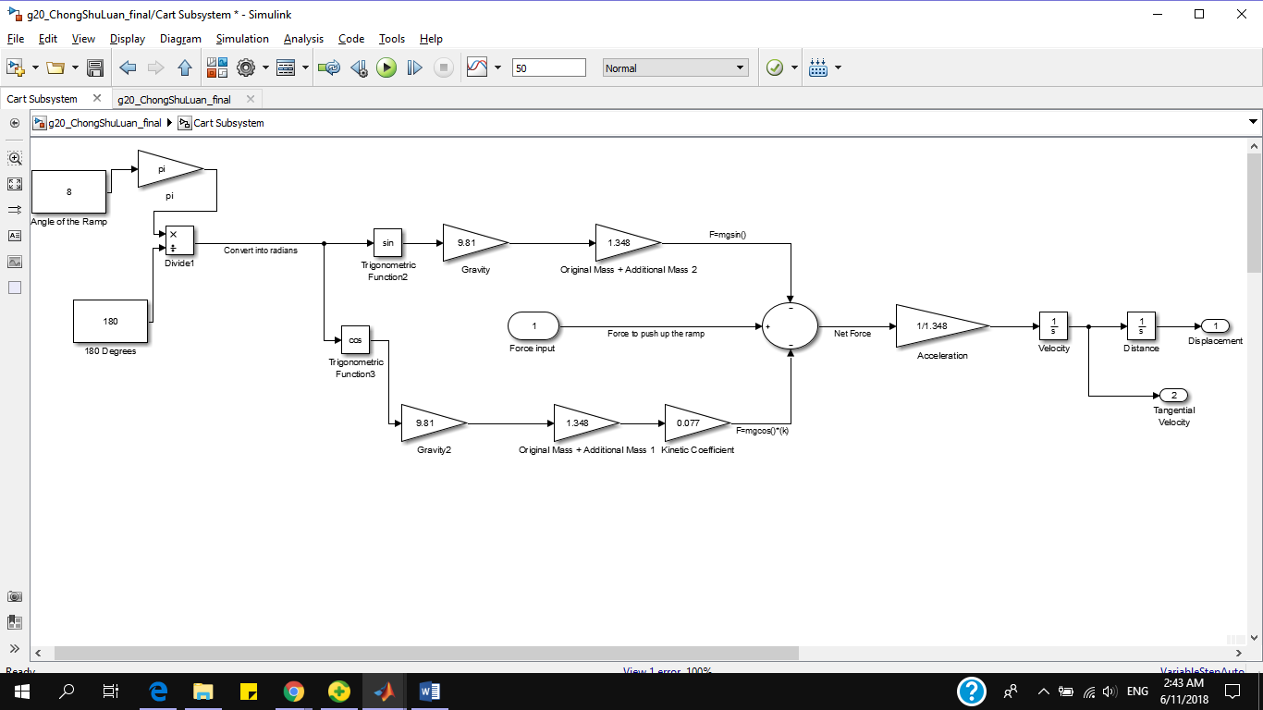
Appendix 2.6 Cart subsystem

